|  |
| --- |
| Surname:  Given Name:  Address:  Phone:  D.O.B: Sex:    **PHYSIO INITIAL ASSESSMENT** |
|  |

**PRESENTING CONDITION:**

________________________________________________________________________________________

Current History:

________________________________________________________________________________________________________________________________________________________________________________

____________________________________________

Past History:

________________________________________________________________________________________________________________________________________________________________________________

Functional Limitations:_________________________

________________________________________________________________________________________

Social Situation (including other services involved):

________________________________________________________________________________________________________________________________________________________________________________

____________________________________________

Lifestyle/activities/sports/hobbies:

________________________________________________________________________________________________________________________________________________________________________________

24 Hour Behaviour:

____________________________________________

Agg/Ease:

____________________________________________

P&N/Numbness:

General Health/PMHx: ____________________________________________________________________________________________________________________________________________________________

Medications:___________________________________________________________________________________________________________

Xrays/Other Investigations:

_______________________________________

**SPECIAL QUESTIONS:**

Unexplained Weight Loss/Gain

Deep Breath/Cough/Sneeze

Headaches

Unexplained weight loss/gain

Dizziness/Diplopia/Dysphagia/Dysarthria/Drop Attacks

Cord/Corda Equina Signs

Clicking/locking/gives way/instability/crepitus

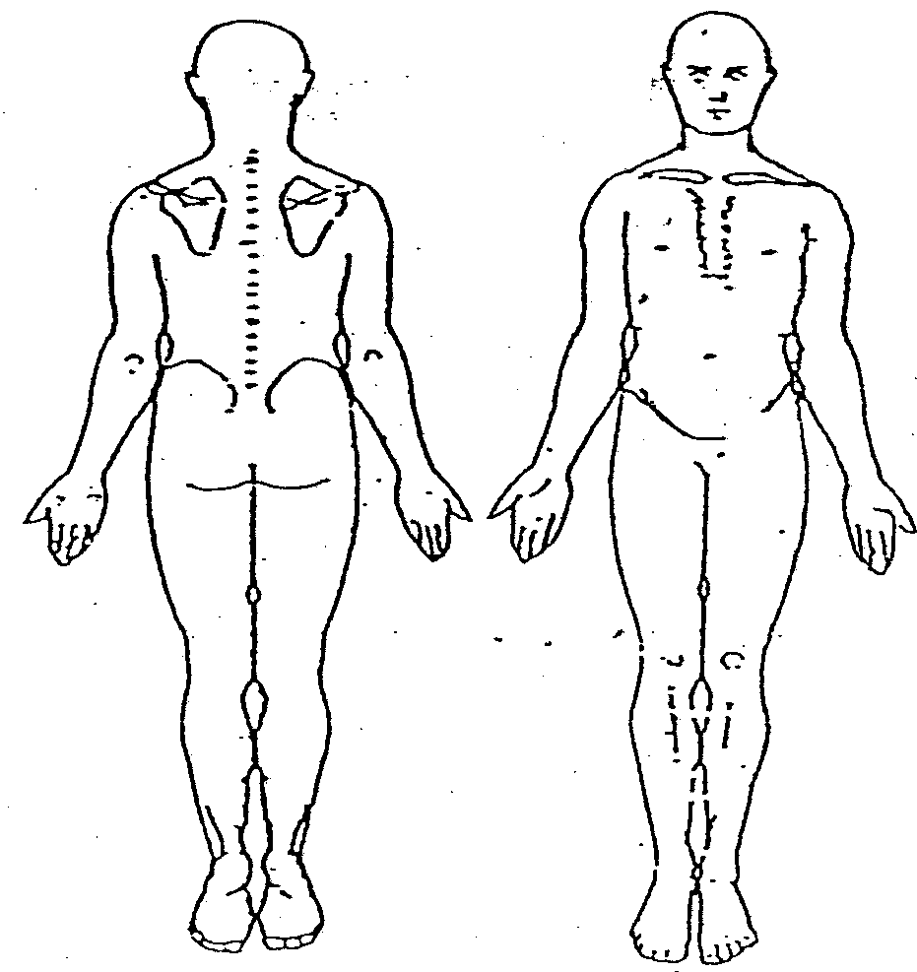

Observation:

Active and Passive ROM:

Palpation:

NEUROLOGICAL ASSESSMENT:

Muscle Strength Tests:

Reflexes: BJ TJ KJ AJ

(L)

(R)

Sensation:

Neurodynamic tests:

Sharp/Blunt: _________________________________

Hot/Cold: ___________________________________

Muscle length:

_______________________________________

OTHER:

**GOAL:**

**PROVISIONAL DIAGNOSIS:**

**TREATMENT:**

**PLAN:**

**Date:**

**Therapist Name:**

**Signature:**