PHYSIOTHERAPY/EXERCISE PHYSIOLOGY ASSESSMENT & CARE PLAN
Is this client actively receiving ANY other services from DACS?
☐ Yes - Allied Health Therapist is required to review client care plan in VisualCare, once VC care plan has been reviewed, AH therapist is to complete assessment
☐ No - Allied Health Therapist is responsible for completing full Assessment/Care Plan
Assessment
Client Name:
Preferred Name: |  |  |  | Date of Birth:
Address:
Phone: |  |  |  | Mobile:
Religion: |  |  |  | Gender: ☐ Male ☐ Female ☐ Other
Email:
Informed Consent: ☐ Yes ☐ No
Date of Assessment: |  |  |  |  | Time of Assessment:
People present for assessment:
Current History:

Past History:

Client Self-Reported Functional Limitations:

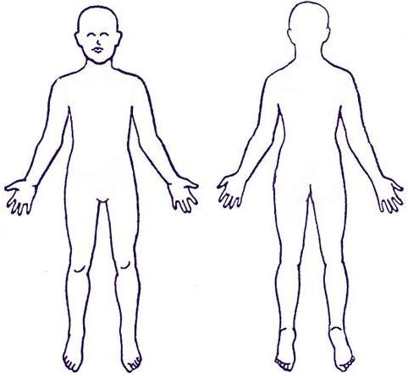
Body Chart:
Special Questions
Spinal cord / Cauda Equina signs: |  |  |  |  |  |  | ☐ Yes ☐ No
Unexplained weight loss / gain: |  |  |  |  |  |  | ☐ Yes ☐ No
Deep Breath / Cough / Sneeze: |  |  |  |  |  |  | ☐ Yes ☐ No
Headaches: |  |  |  |  |  |  | ☐ Yes ☐ No
Dizziness / Diplopia / Dysarthria / Dysphagia / Drop attacks: |  |  |  |  |  |  | ☐ Yes ☐ No
Clicking / Locking / Giving Way / Instability: |  |  |  |  |  |  | ☐ Yes ☐ No
Pins & Needles / Numbness / Sharp shooting pain: |  |  |  |  |  |  | ☐ Yes ☐ No
Details (if any are yes):

Pain (24 hour behaviour, aggravators/eases):

Medications:

Social History (lifestyle / activities / sports / hobbies:

Typical exercise tolerance:

Stairs:

Falls history:

Services:

X-rays/Other investigations:

Environment
Stairs | Front: |  |  |  |  | Rail:
 | Internal: |  |  |  |  | Rail:
 | Rear: |  |  |  |  | Rail:
Details:

Observation
Joint ROM:
MMT:
Palpation:
Special Tests:
Sensation:
Hot / Cold:
Gait pattern:
Gait aid/s:
Timed Up and Go:
30 sec STS or 5 x STS test:

Balance: |  | Eyes open: | Feet together: |  |  |  |  | Feet apart:
 |  | Eyes closed: | Feet together: |  |  |  |  | Feet apart:
 |  | Tandem stance: | R) foot forward: |  |  |  |  | L) foot forward:
Other:

Goals:

Treatment plan:

Equipment recommendation:

Plan:

Clinician Name:
Role:
Signature:
Date:
CARE PLAN
Client Name: |  |  |  |  | Preferred Name:
Date of Birth: |  |  |  |  | Religion:
Client Representative Details
Full Name: |  |  |  |  | Relationship:
Address:
Phone: |  |  |  |  | Mobile:
Email:
Treating Physiotherapist/Exercise Physiologist Details
Full Name: |  |  |  |  | Phone number:
ACAT: ☐ Yes ☐ No |  |  |  |  | MAC Referral Number:
Date of Care Plan: |  |  |  |  | Review Date:
Medical Health Needs
Doctor Name: |  |  |  |  | Practice Name:
Address:
Phone Number: |  |  |  |  | Email:
Allergies:
Alerts:
Dignity of Risk:
IN THE EVENT OF AN EMERGENCY PLEASE CONTACT 000 FOLLOWED BY MY CONTACTS OUTLINED BELOW
Contact One: |  |  |  |  | Contact Two:
Phone: |  |  |  |  | Phone:
Plan for Non-Response to a Scheduled Visit
☐ | Repeat Knocking |  | ☐ | Call Contacts Above |  | ☐ | Call Client
☐ | Contact Police |  | ☐ | Contact Neighbour |  | ☐ | Access via Key Safe
☐ | Other |  |  |  |  | Key Safe Code:
Communication
Primary Language: |  |  |  |  | Other Language:
☐ | Coherent/Clear |  | ☐ | Jumbled |  | ☐ | Reduced Content
☐ | Word Finding Difficulty |  | ☐ | Converses with Others |  | ☐ | Able to Communicate Effectively
Additional Comments:

Mobility
☐ | 4 Wheel Walker | ☐ | Walking Stick |  | ☐ |  | Wheelchair
☐ | Nil Walking Aids | ☐ | Independently Mobile |  | ☐ |  | Other
If Other, please specify:
Assessment Completion
Physiotherapist/Exercise Physiologist Name:
Date:
Signature:
Client Name: |  |  |  |  |  | Date:
Signature:
Client Representative Name: |  |  |  |  |  | Date:
Client Representative Signature:
Review Schedule
Is a review required? ☐ Yes ☐ No |  |  |  | Scheduled Review Date:
Review Completed by: |  |  |  |  |  | Date:
Role:
Signature:
Comments:

