STAIR LIFT ASSESSMENT
Client Name: | Date of Birth:
Occupational Therapist: | Date of Ax:
Reason for Referral:
Goals:
Improve access within home environment
Ability to access community
Other: _________________________________________________________________________________
Social Situation: Lives alone With spouse With family
Funding: CHSP HCP Private
Do they hold a: Full Pension Part Pension DVA Gold Card
Medical History:
Falls History:

Mobility:
Level of Assist:  - Independent  - Supervision  - 1x A  - 2x A | Aids:  - Unaided  - WS  - 4WW  - Forearm support frame  - MWC  - PWC
Anthropometrics:
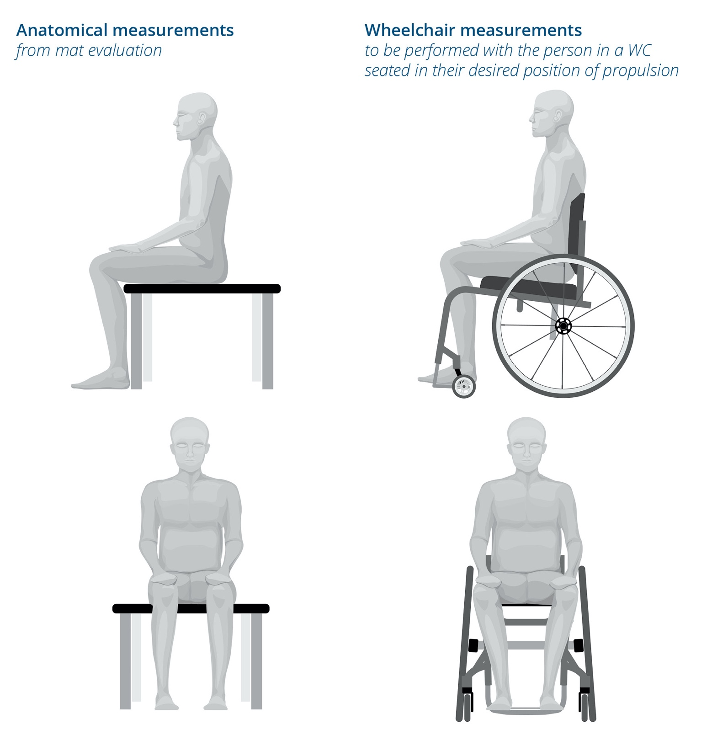  1  4  2  3 |  | User Height: ________cm  User Weight: ________kg  - Seat to top of head: ________mm  - Back to Knee: ________mm  - Popliteal Height: ________mm  - Back to Toe: ________mm
Function:
Time taken to ascend stairs: _________________
Time taken to descend stairs: ________________
Dexterity:
Client can operate stair lift independently  Manual footplate and swivel | Assistance required to operate stair lift  Automatic footplate and swivel required

Cognition:
Intact Dementia Other cognitive impairment
Specify:
Is trial required?
Is there someone else who can operate the stair lift?
HOME ENVIRONMENT
Home Description:
Privately owned
Rental Gain approval
Dept. of Housing Send referral to DOH
Site Details:
Location of Stairs:  Front Rear Internal  Number of Steps: _____________________  Staircase is:  Straight Curved Outdoor  Material:  Wood Concrete Tile  Marble Granite Steel Carpet  Is there a powerpoint within 5m of stairs?  Yes No – one needs to be installed  Location of powerpoint:  Top of stairs Bottom of stairs  Under stairs Next room | Length of Staircase: _____________mm  Width of Staircase: _____________mm  Clearance at base of stairs: _____________mm  Clearance at top of stairs: ______________mm
*ATTACH IMAGES AT BASE OF FORM.

Additional Comments:
OT Recommendations:
Stair lift is recommended
Stair lift is not recommended
Alternative:

Therapist: | Signature:
Date:

Images of Environment:

